EE / CprE / SE 492 Weekly Report

October 3 - October 13

sddec24-16

Designing a Smart Plant Nurturing System Enabled by IoT Technology

Faculty Advisor / Client: Md Maruf Ahamed

**Team Members:**

* Tejal Devshetwar - Frontend
* Holden Brown - Frontend/backend
* Blake Hardy - Backend
* Cameron Jones - Backend
* Cayden Kelley - Hardware
* Chase O’Connell - Hardware

**Summary of Work:**

This past week, we were able to get our NPK sensor working by testing with an Arduino and related libraries instead of MicroPython on the Pi Pico W. This was a major accomplishment, as we have been struggling with obtaining data from the sensor over Modbus for quite some time. This helped us decide to use an Arduino as the primary microcontroller instead of a Pi Pico after re-weighing the pros and cons of each. Working with setting up the watering system, we ordered pipe size converters after recognizing zip ties were not a strong solution. We also identified the need to search for a different moisture sensor, as our current one from Adafruit is low quality and has exposed electronic components.

**Work Period Accomplishments:**

* During this week we managed to get the NPK sensor communicating legibly with our microcontroller by switching to an arduino nano borrowed from the ETG.
* This switch then led us to purchasing an arduino maker series as the permanent replacement to the Pi Pico.
* The seeds were planted for initial testing.
* The pumps were activated based on moisture sensor data.
* The need for a better moisture sensor was noted.

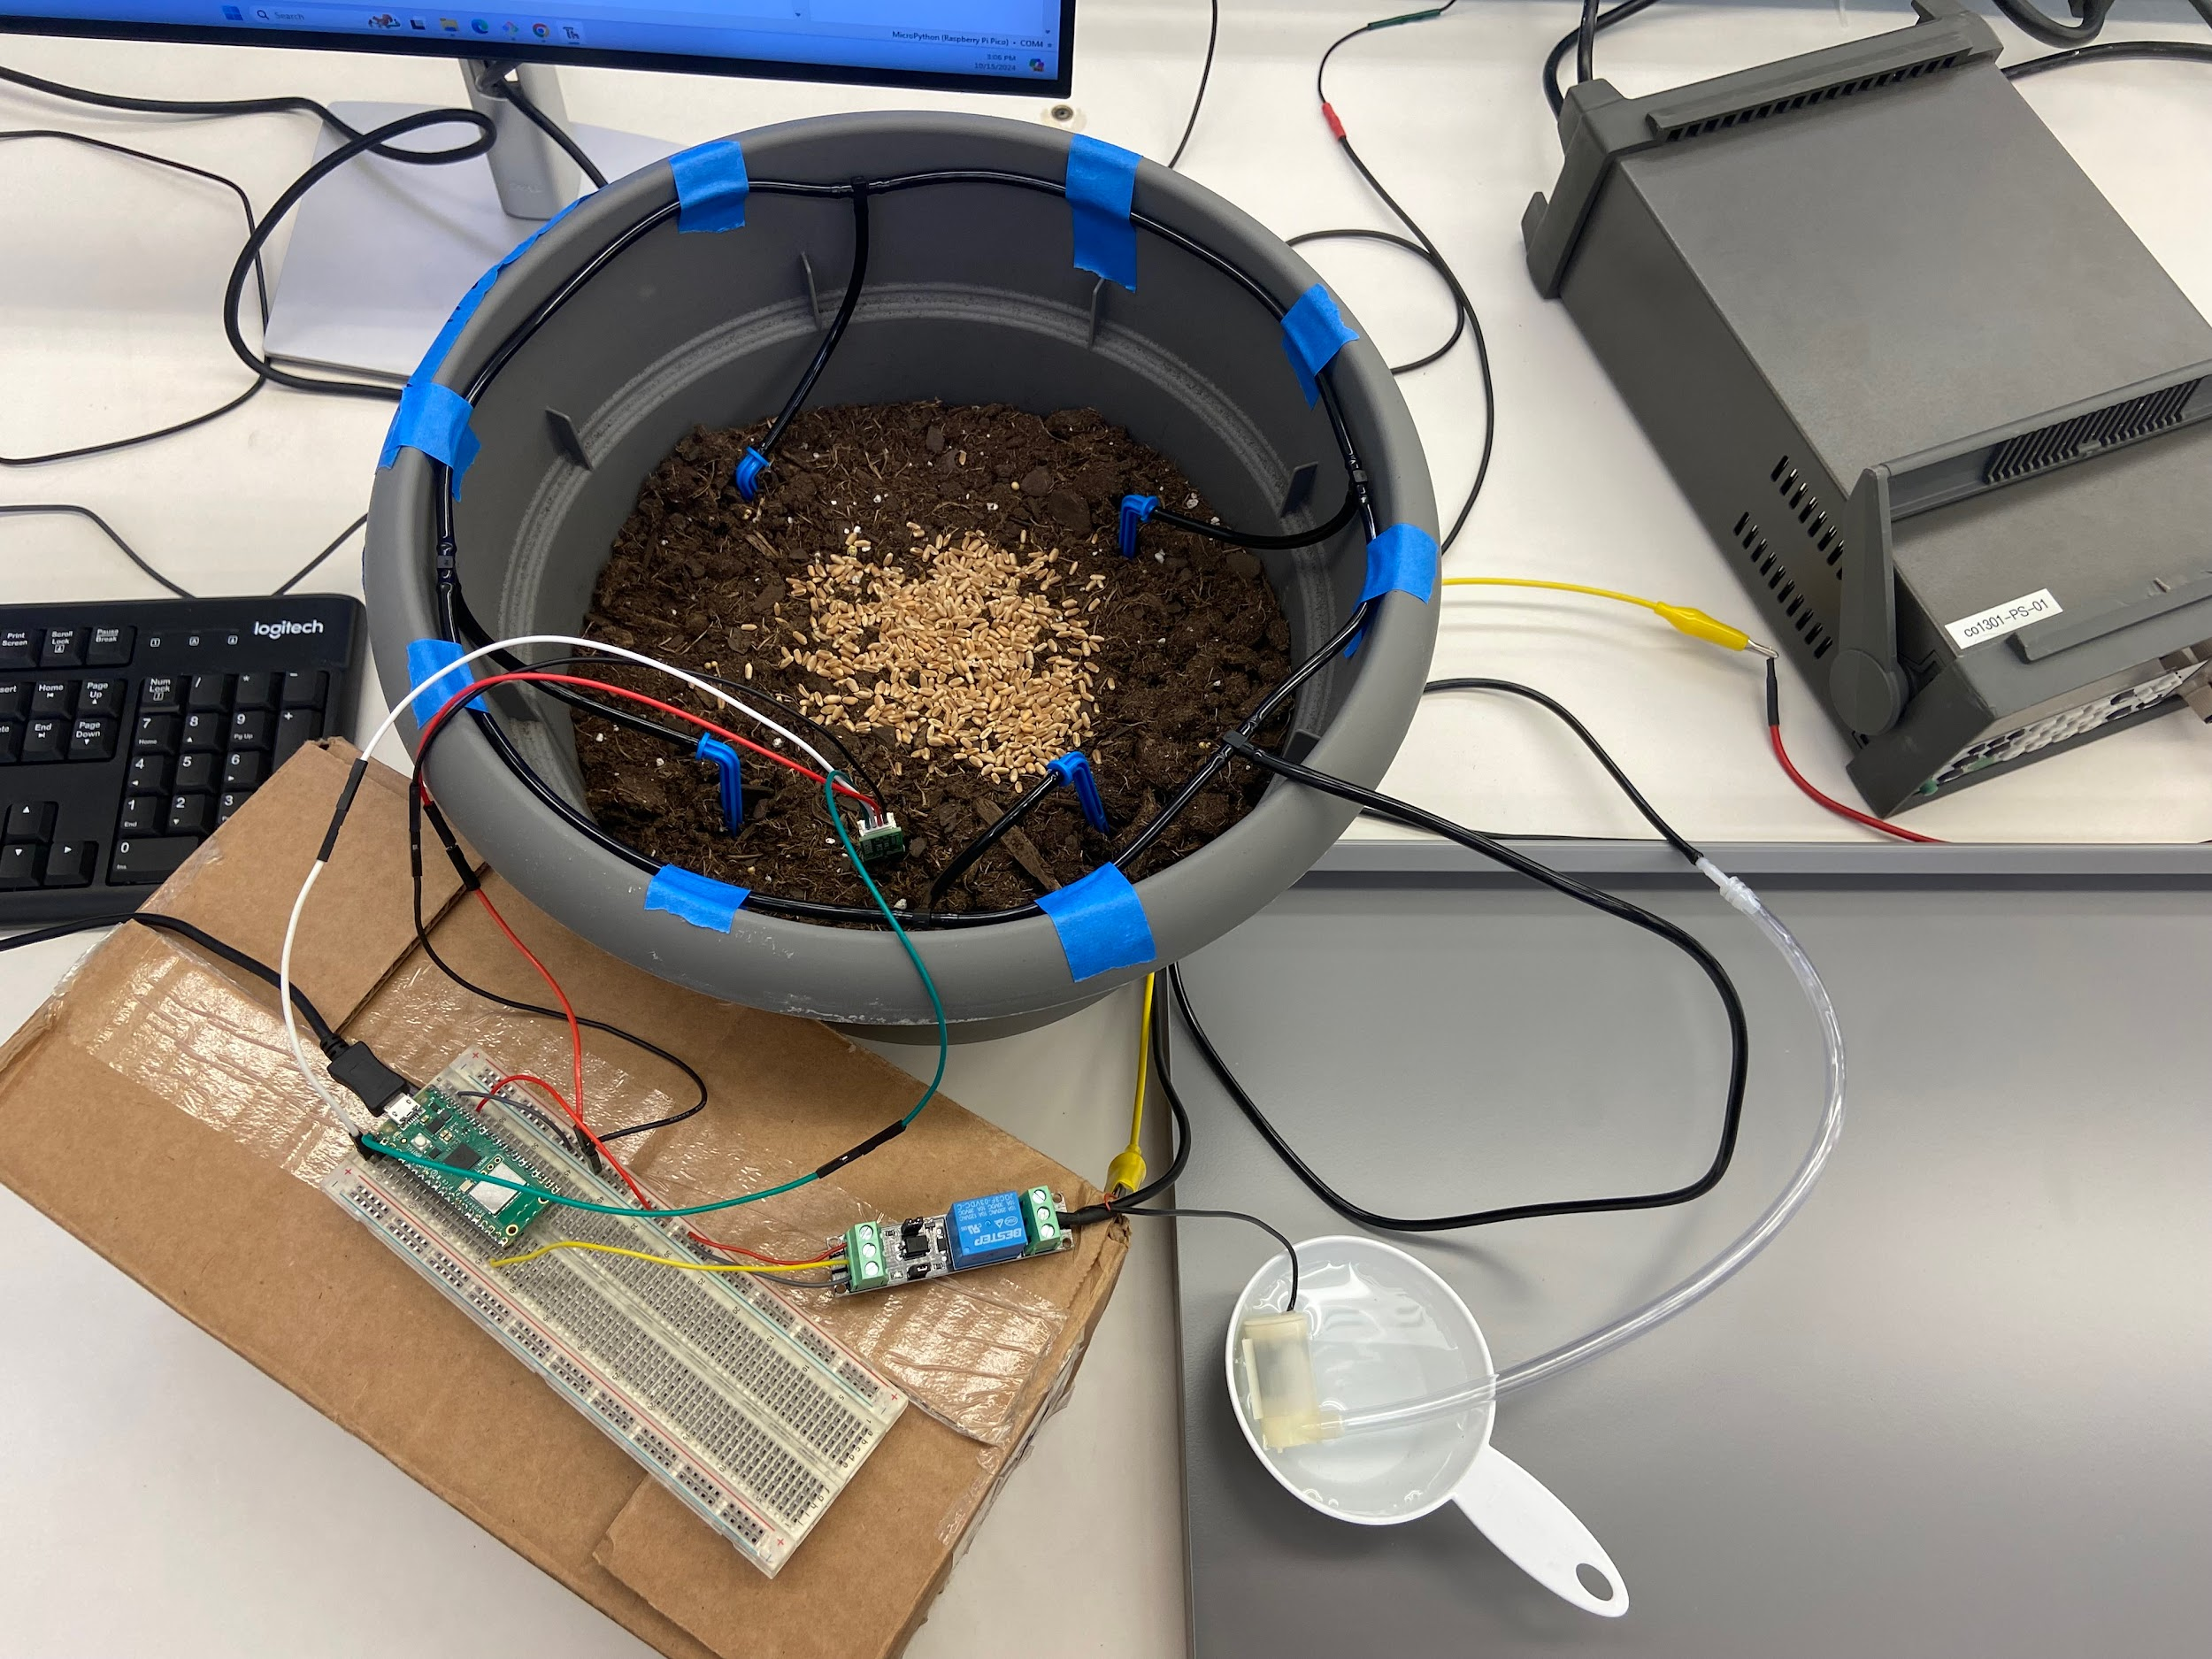

Figure 1: Watering Test Setup with Wheatgrass

**Plans for Coming Week + Action Items:**

* Holden Brown - Get round trip software working.
* Tejal Devshetwar - Get started with looking at how to set up the websocket communication. Find other alternative methods as well to connect which might be easier to implement in comparison to websockets.
* Blake Hardy - Get arduino sending http requests to the server and logging data, talk to software to see how they want data formatted and where exactly the server is. Get full loop working and allow the arduino to receive and act on commands. Look into using ADCs to measure motor current with shunt resistors and a few status indicator LEDs to easily diagnose errors. Look into low power library to enable device to sleep while inactive. See if its still possible for real time remote control of device via websockets on the significantly less powerful arduino hardware. We’ll see what gets done, my time is pretty limited this week.
* Cameron Jones - Work on getting full loop working. Perform research on websockets to see if they can still work, maybe see about using pico as a websocket slave.
* Cayden Kelley - Get the moisture sensor and Raspberry Pi Pico working to begin collecting data and watering the soil based on this data.
* Chase O’Connell - Get initial data for watering system calibration. Look at potential other sensors for moisture to fit within the watering system.

**Pending Issues:**

* Tejal Devshetwar
  + No issues
* Holden Brown
  + No issues
* Blake Hardy
  + Arduino is unable to connect directly to the university wifi, will probably just run it on a hotspot. Apparently IT is really slow with these sorts of requests.
* Cameron Jones
  + Still having difficulty working with university wifi.
* Cayden Kelley
  + No issues
* Chase O’Connell
  + No issues

**Individual Contributions:**

| Team Member | Contribution | Weekly Hours | Total Hours |
| --- | --- | --- | --- |
| Tejal Devshetwar | – | – | 27 |
| Holden Brown | – | – | 50 .4 |
| Blake Hardy | Tried to get pico modbus working one last time and failed. Borrowed an arduino from ETG and got it working in a couple hours. Ordered new microcontroller, planning for enclosure, fittings, and maybe additional sensors. | 8 | 44 |
| Cameron Jones | Worked with Blake to get the modbus working with the pico. Switched to arduion. Planned enclosure. Researched related embedded concepts | 8 | 40.6 |
| Cayden Kelley | Worked with the NPK sensor to understand the type of data it returns, and the effects different soil types and moisture contents have on the reading. Also briefly worked with Blake and Cameron to get the NPK sensor working with the Arduino. | 3 | 56.6 |
| Chase O’Connell | Set up pipe system to test watering and ordered pipe size converters to make pumps compatible with irrigation system. Set up main electronics again for testing. | 4 | 39.5 |